Challenges – Git
Resolve Merge Conflicts
a.Create a merge conflict intentionally (two users editing the same line).
- First I have created a repository “challenges-git”
Git init challenges-git
cd challenges-git/
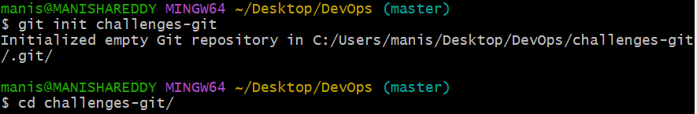
- Created a file challenge1.txt
vi challenge1.txt
git add challenge1.txt
git status
git commit -m “added a file”
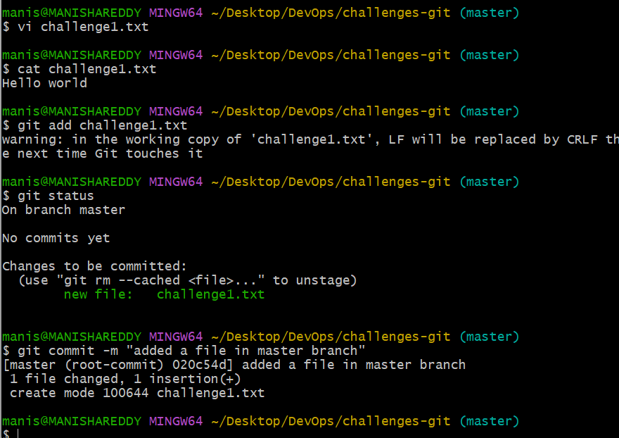
Next I have created the branch
Git checkout -b branch – It creates and get into that branch
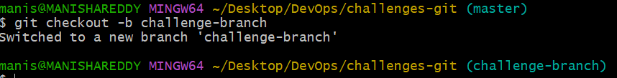
Edited challenge1.txt file and commited it
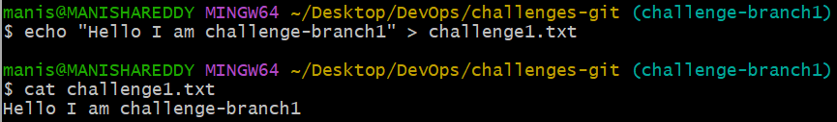
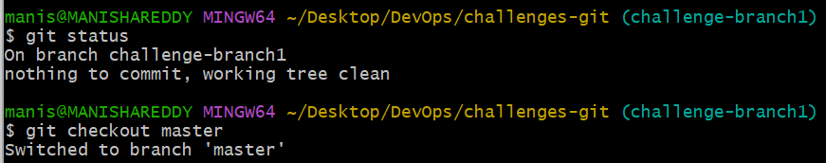
I have created one more branch “challemge-branch2”
Edited a challenge1.txt, then added and commited it
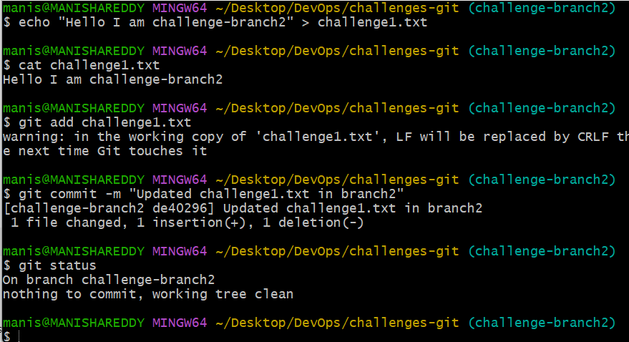
Merging challenge-branch1 to master branch
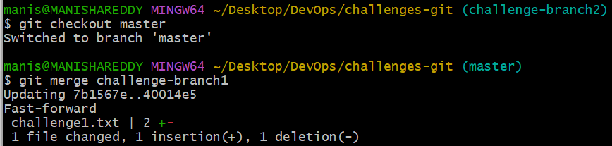
Merging challenge-branch2 to master branch
Here I am facing conflict
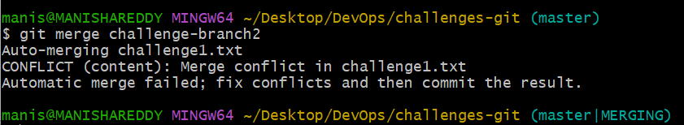
Opened challenge1.txt
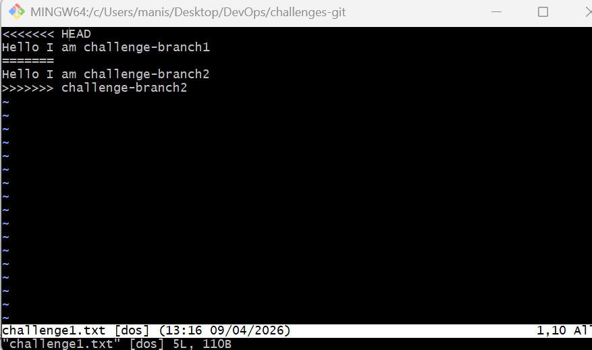
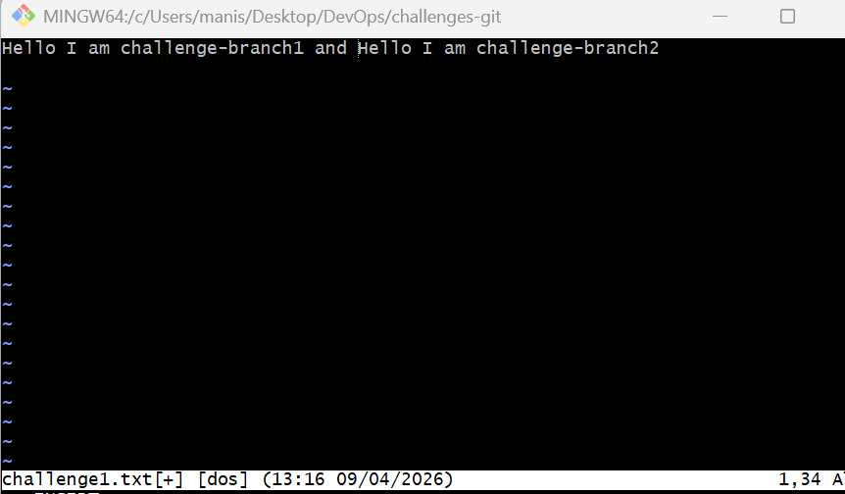
Git log –oneline : To get the status whether the merge conflict is resolved or not
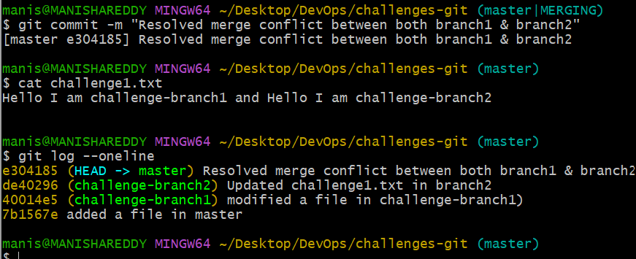
Resolve the conflict and push the changes.
I have checked the merge conflict

I have pushed the resolved merge conflict to github.
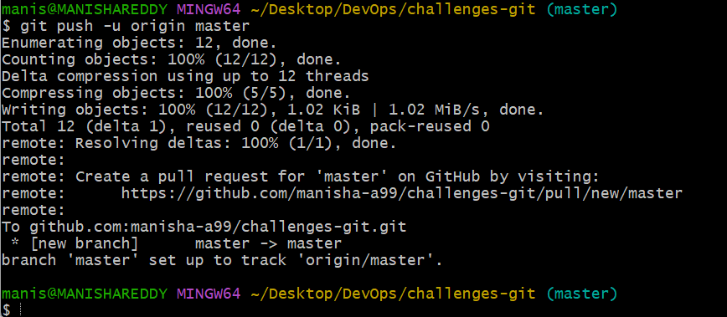
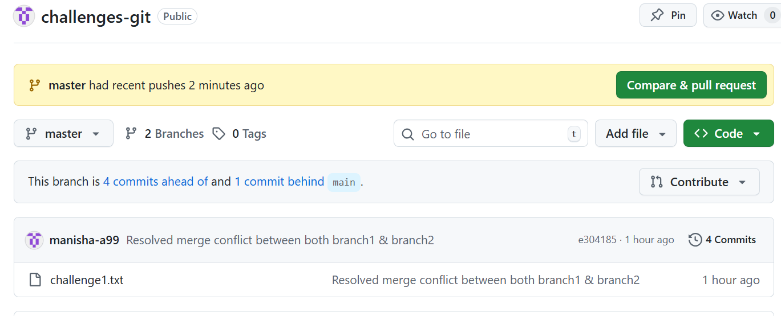
2. Recover Deleted Branch
Delete a local branch and then recover it using the reflog.
I have deleted challenge-branch1 using
Git branch -d challenge-branch1
git reflog – I have found the commit id and copied it
I gave back the branch name with commit id and finally I have recovered it.
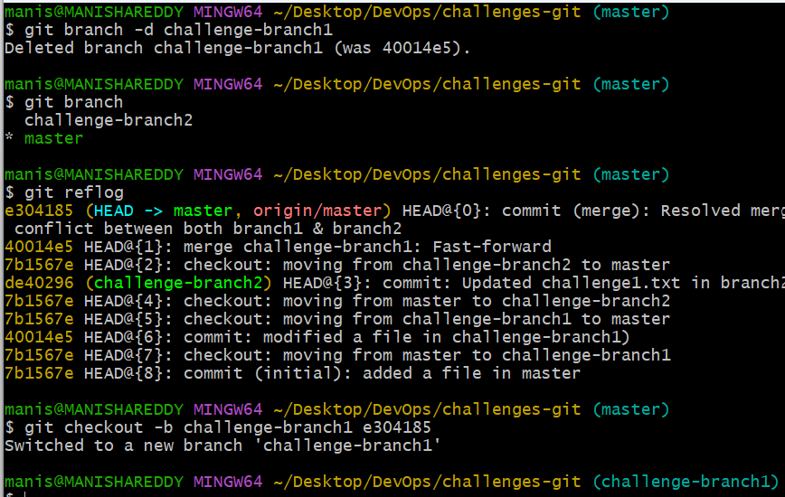
3. Undo Wrong Push
Push a wrong commit to GitHub, then undo it without losing history.
I have created a file manu.txt and added, committed it.
Next I have pushed to github
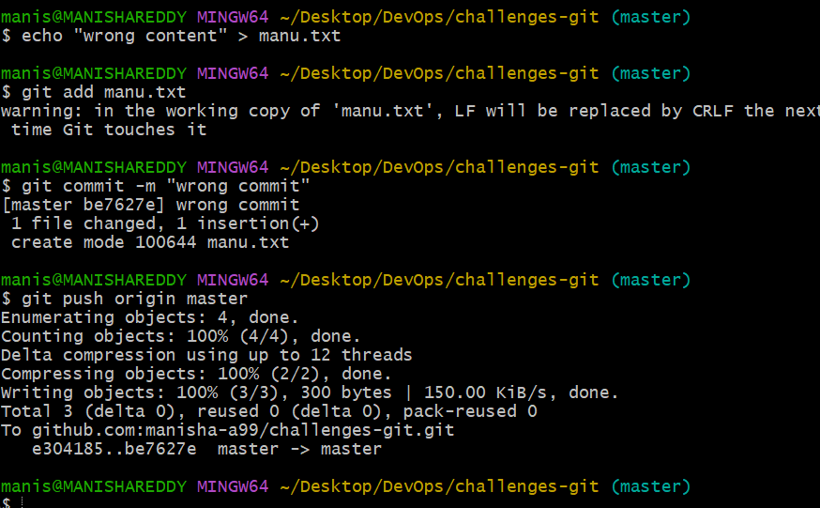
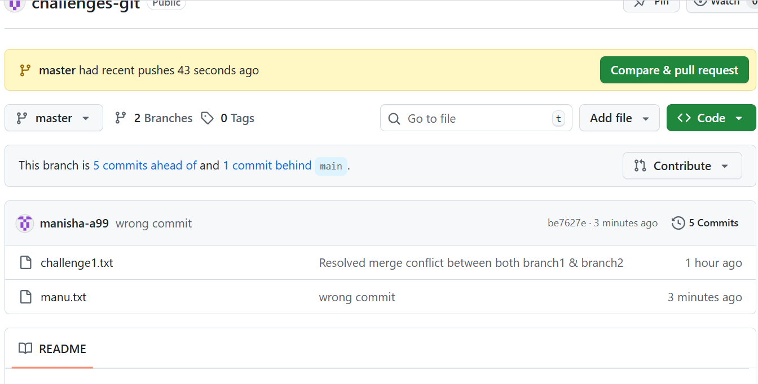
I have reverted it
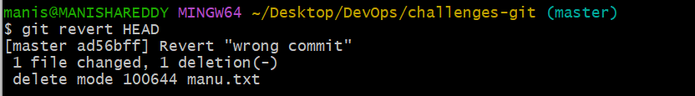
Next I have pushed it to github
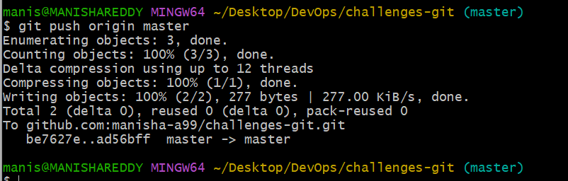
Checked in github
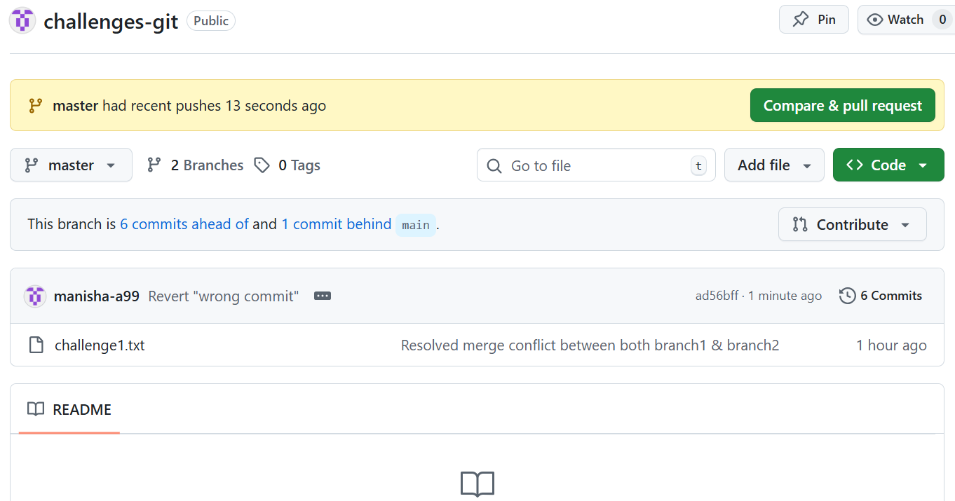
5.Amend a Commit
Make a commit, then add a missing file to it using git commit --amend.
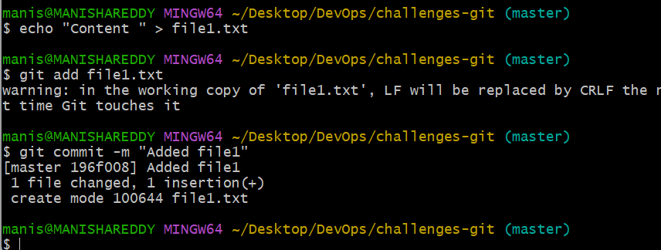
Above I have forgot to add another file but I have committed it.Instead of creating a new commit I have updated the commit using amend
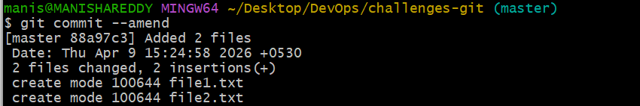
Here I have edited my commit message
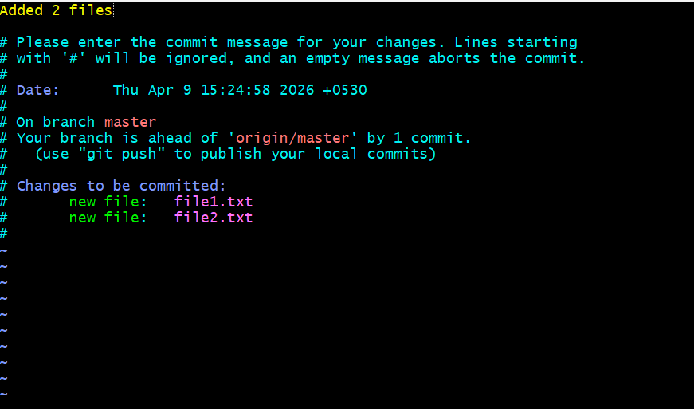
I have checked the commit.
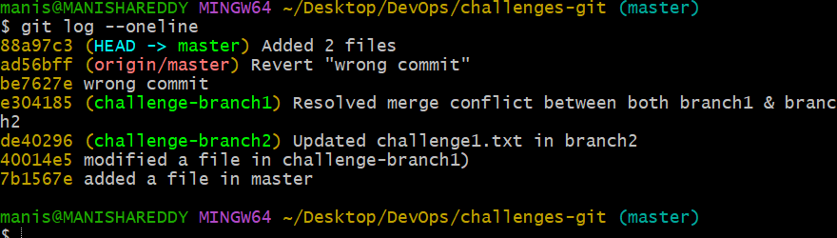

6. Cherry-pick a Commit
Take a specific commit from one branch and apply it to another branch.
First I have opened the list of logs and took the commit which I want to add.
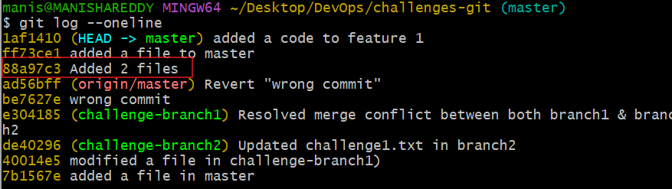
Now I have changed to another branch
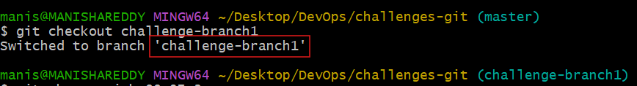
Here I want to apply a specific commit which I want to add.So I have used the below command to apply
Git cherry-pick <commitid>
Next checked the logs whether the commit id is added or not.
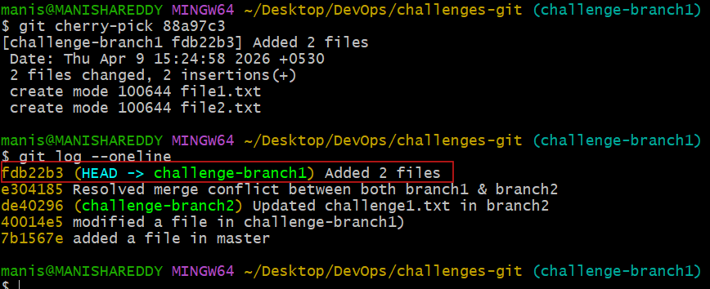
7.Interactive Rebase
Reorder and squash multiple commits into a single clean commit.
I have opened the list of logs and I want to squash below 3 marked commits to a single commit
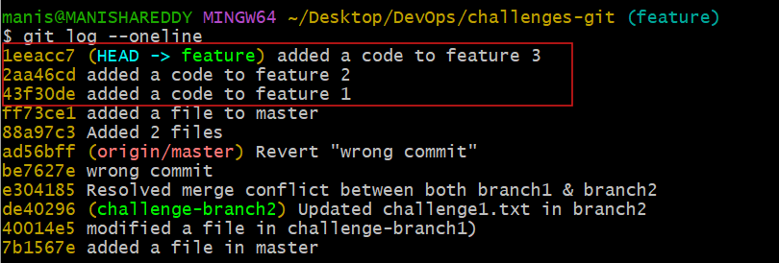
Here I have modified for squash by using rebase command
Git rebase -I HEAD~3
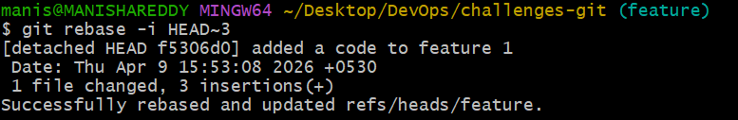
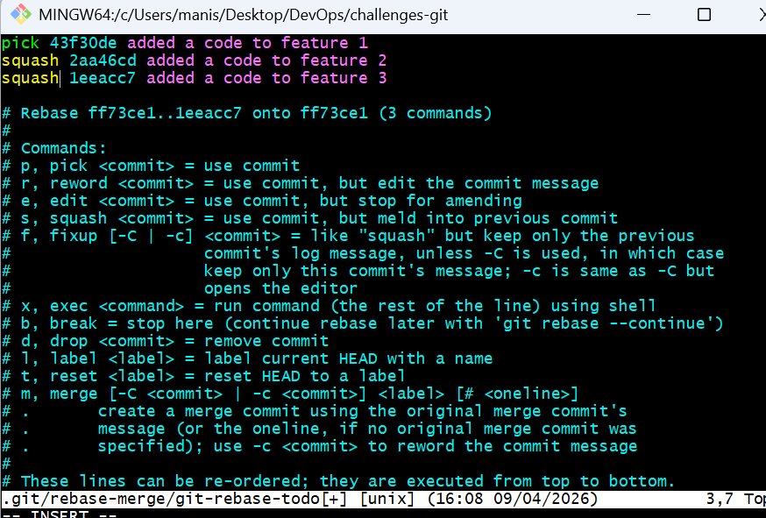
Now I have verified the log
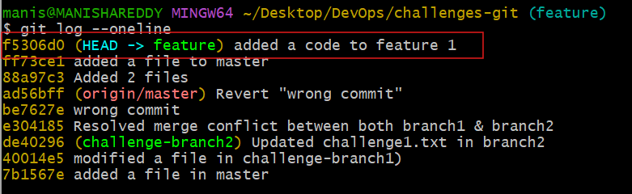
8. Tagging & Release
Create a version tag (v1.0), push it to GitHub, then delete and restore it.
-I have created a file name app.txt. I have added and committed it.
- Next I have created a tag
- Pushed it to github

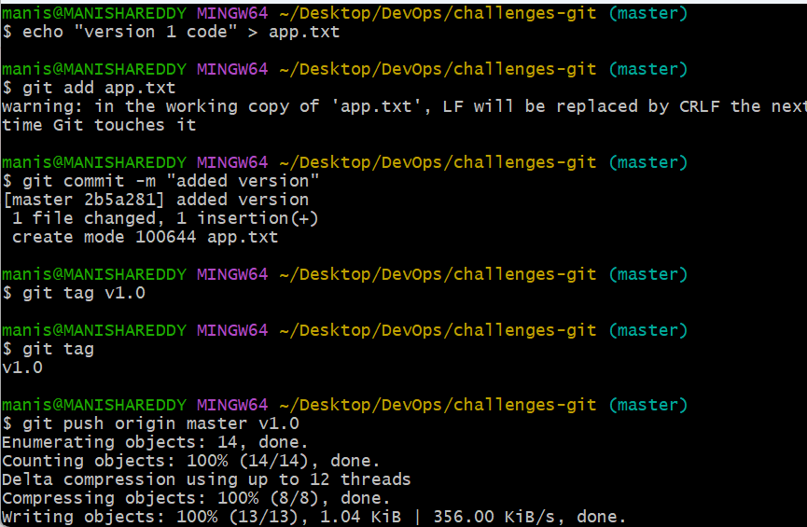
- Verified whether the tag is pushed into github
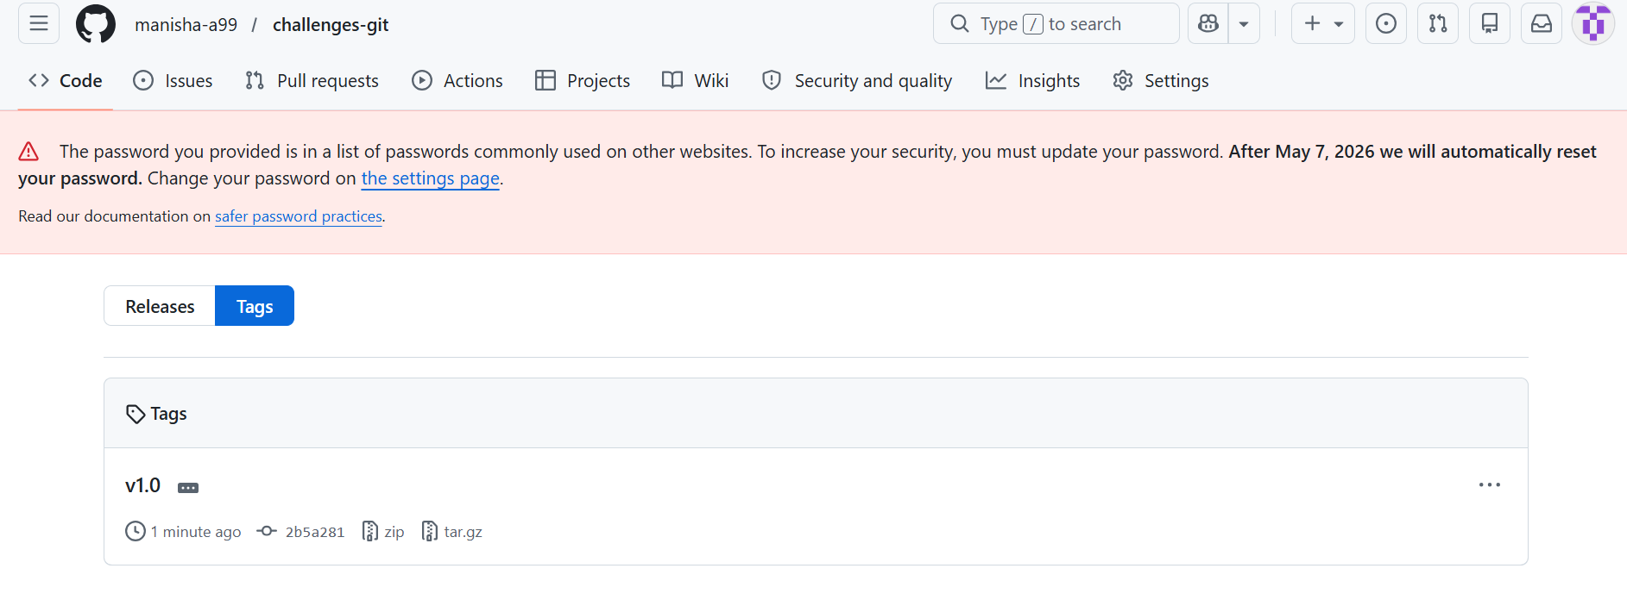
- I have deleted tag from local and github
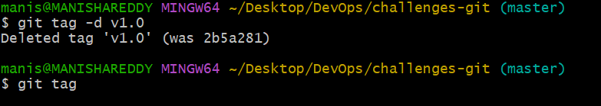
- I have picked the commit id and reverted the version back and pushed it to github
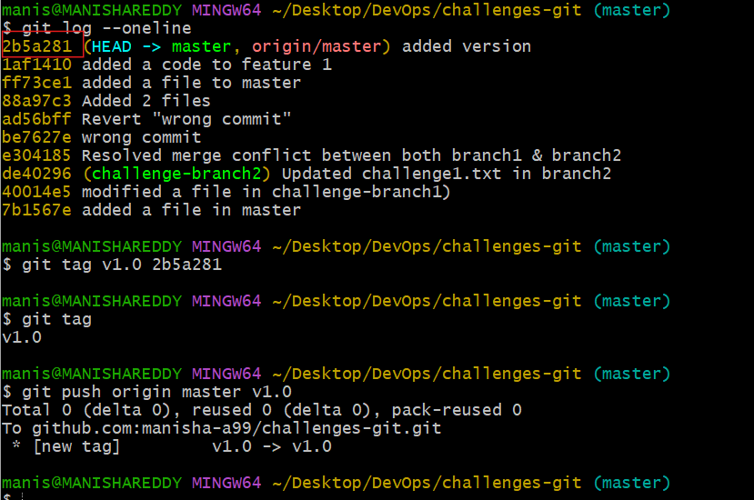

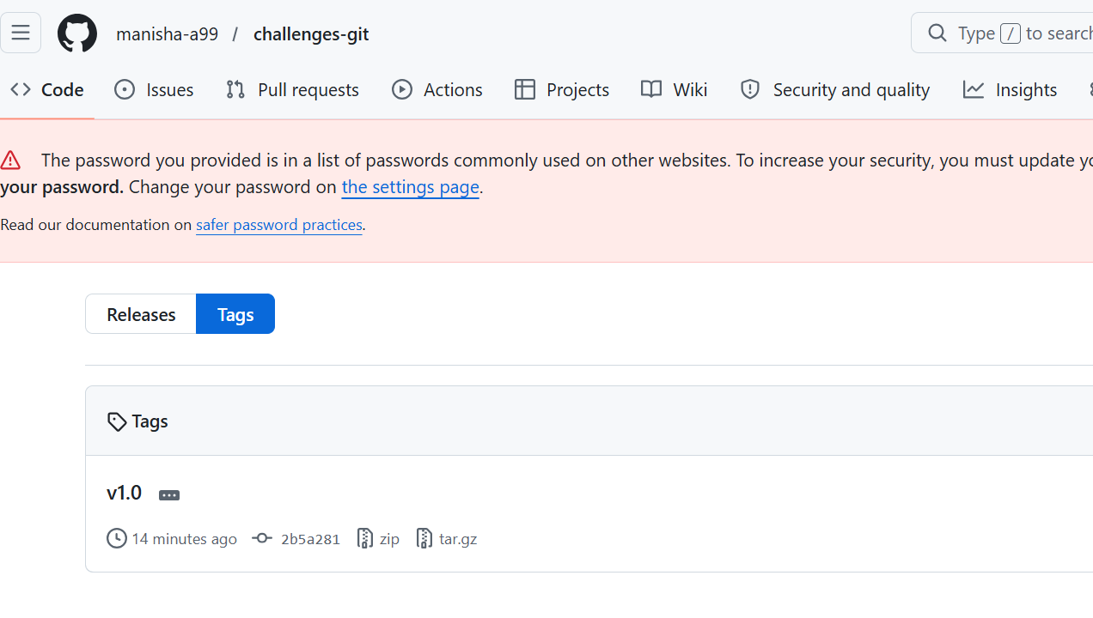

10.Reset vs Revert Challenge
Demonstrate the difference between git reset --hard and git revert in a repo.
git reset –hard : removes commits and changes completely from history
git revert : creates a new commit that undoes the changes without deleting history
git reset –hard : Here I have used this command and I tried to reset the latest commit. It was removed completely.
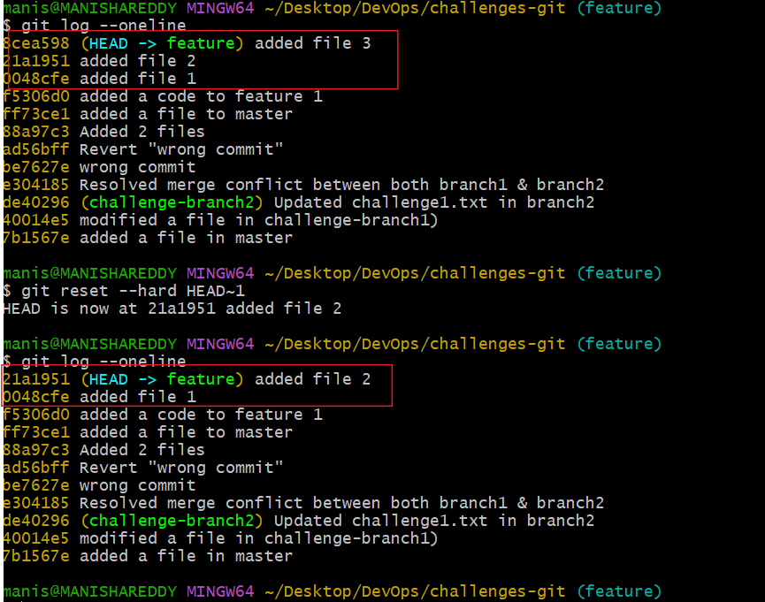
Git revert
Here I am trying to revert this below commit by using revert command
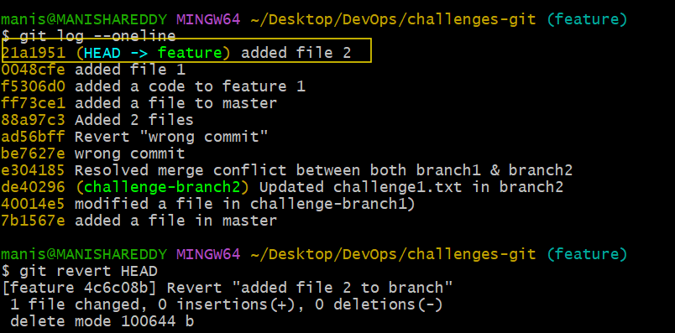
This is the commit before changes.
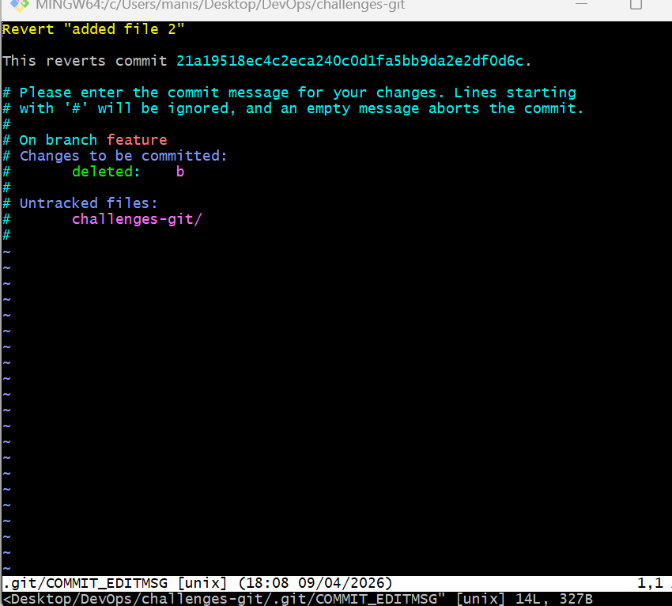
I have edited this commit
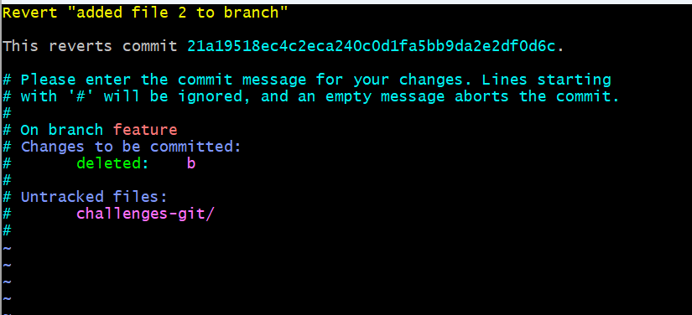
I have verified logs whether the commit is reverted or not
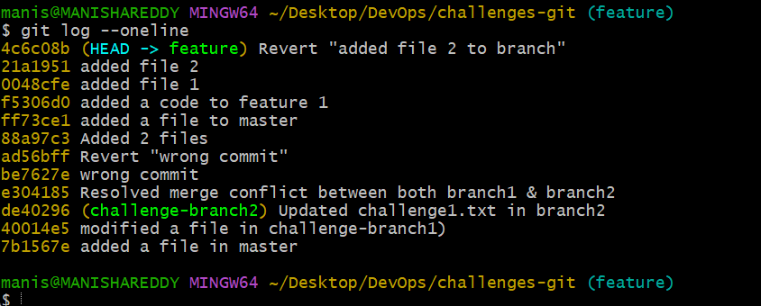
11.Detached HEAD Challenge
Checkout a specific commit (detached HEAD state) and create a new branch from it.
I have selected a specific commit to detach
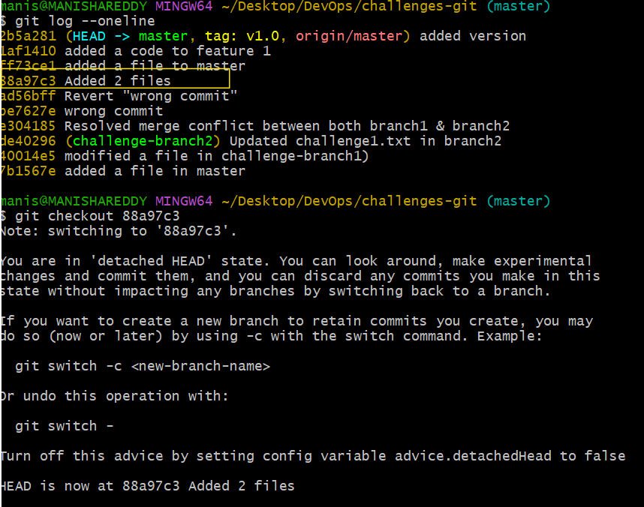
- I have made changes in detached state
- It switches to commit
- Created a new branch and verified
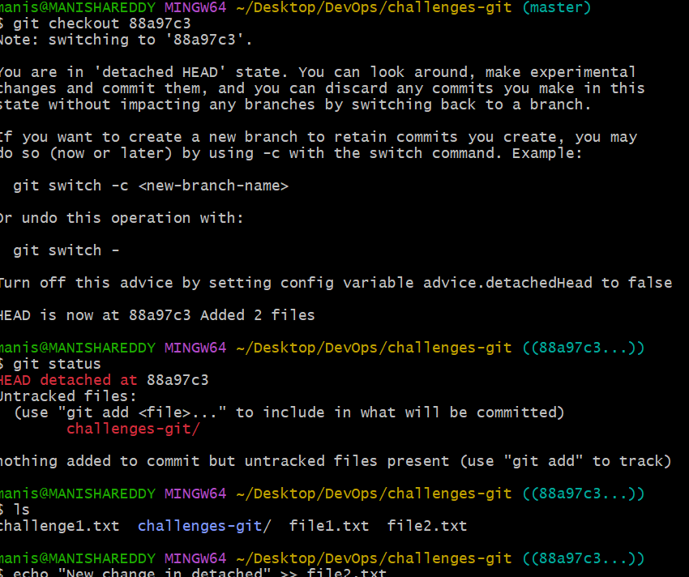

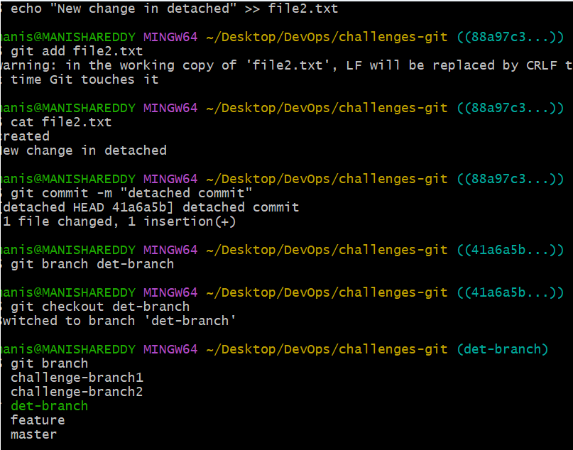

12.Git Hooks Challenge
Configure a pre-commit hook to reject commits without a message format (e.g., must start with JIRA-XXX).
- First we need to navigate to hooks folder
- Create hook file

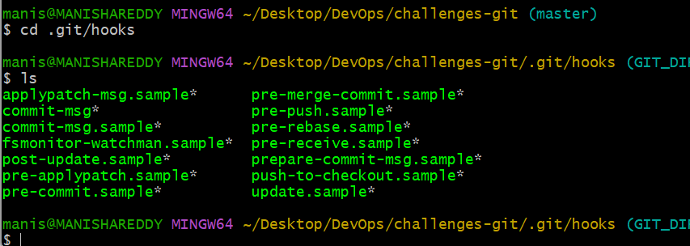
- Add script
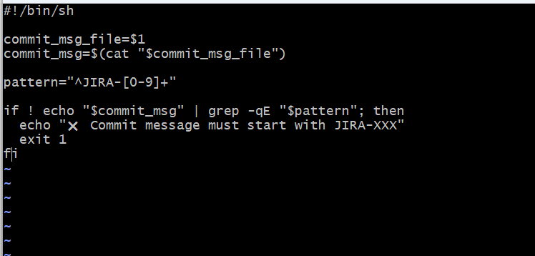
- Make it executable
- chmod +x commit-msg
- Testing hook
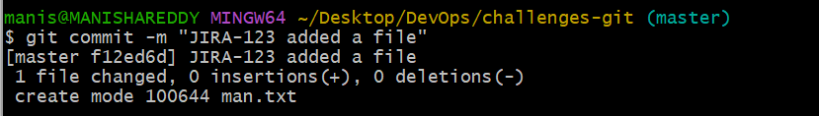
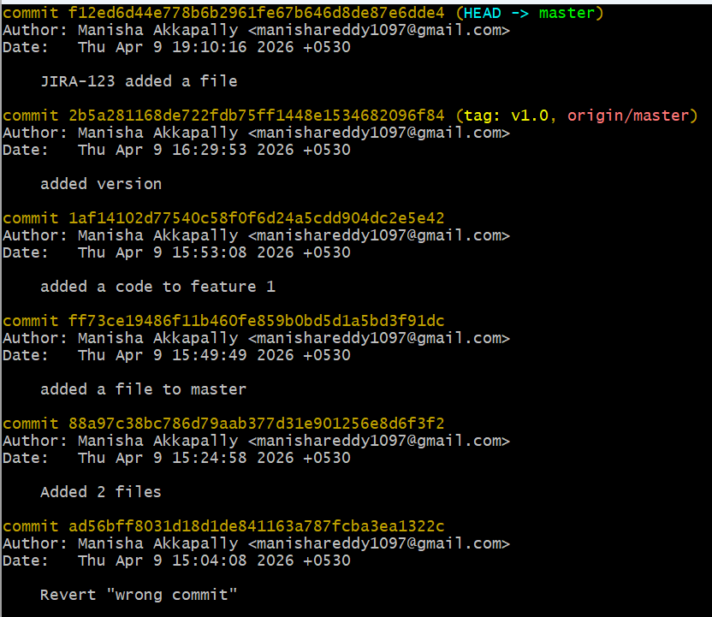

13.Squash Merge vs Rebase Merge.
Show the difference between squash merge and rebase merge with evidence
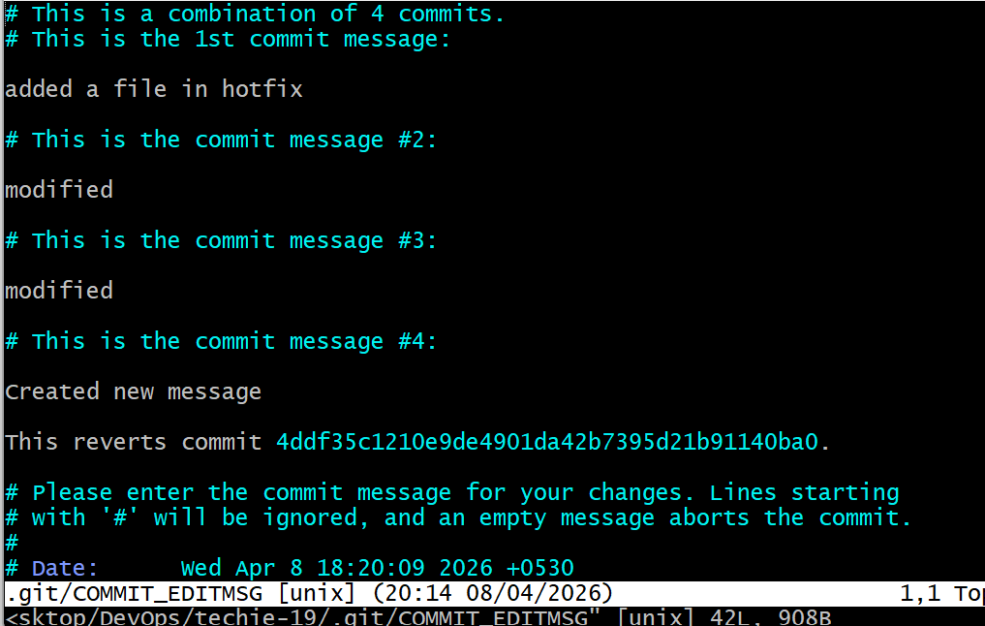

14Fork & Pull Request Workflow
Fork a repo, make a change, and submit a pull request to the original repo

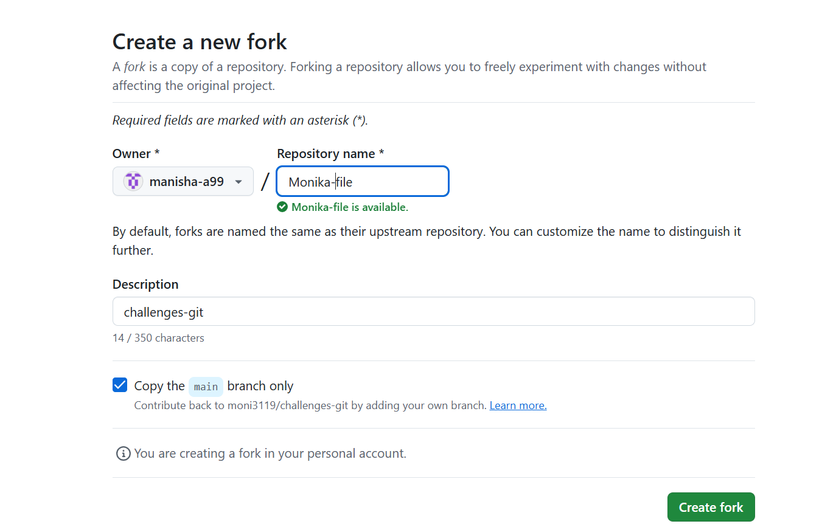
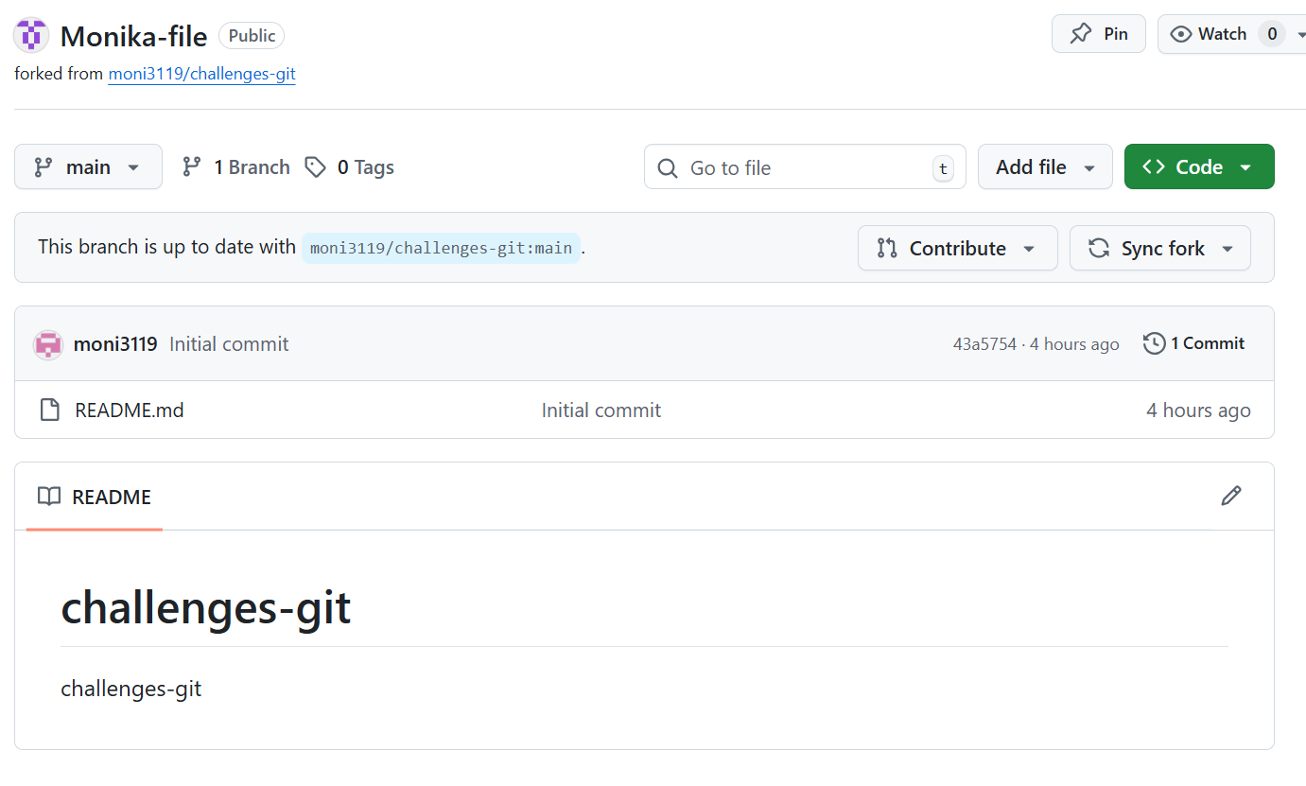
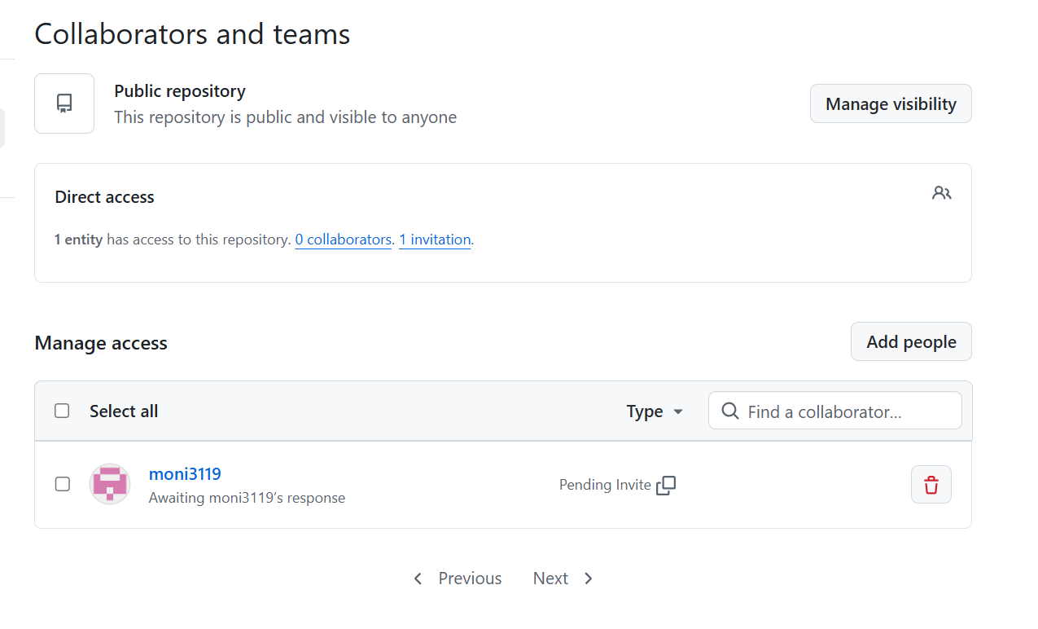
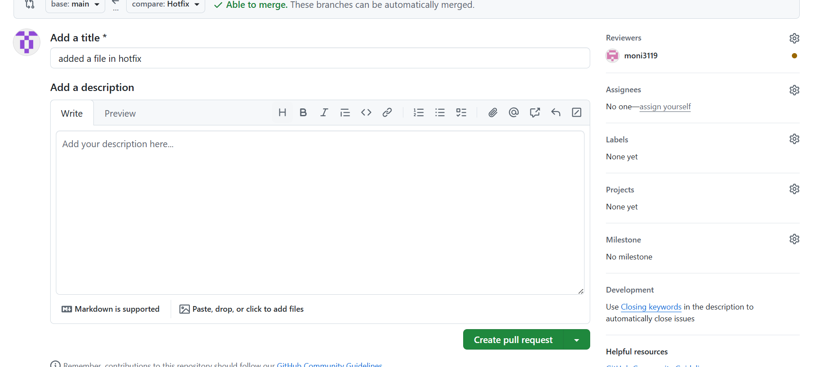
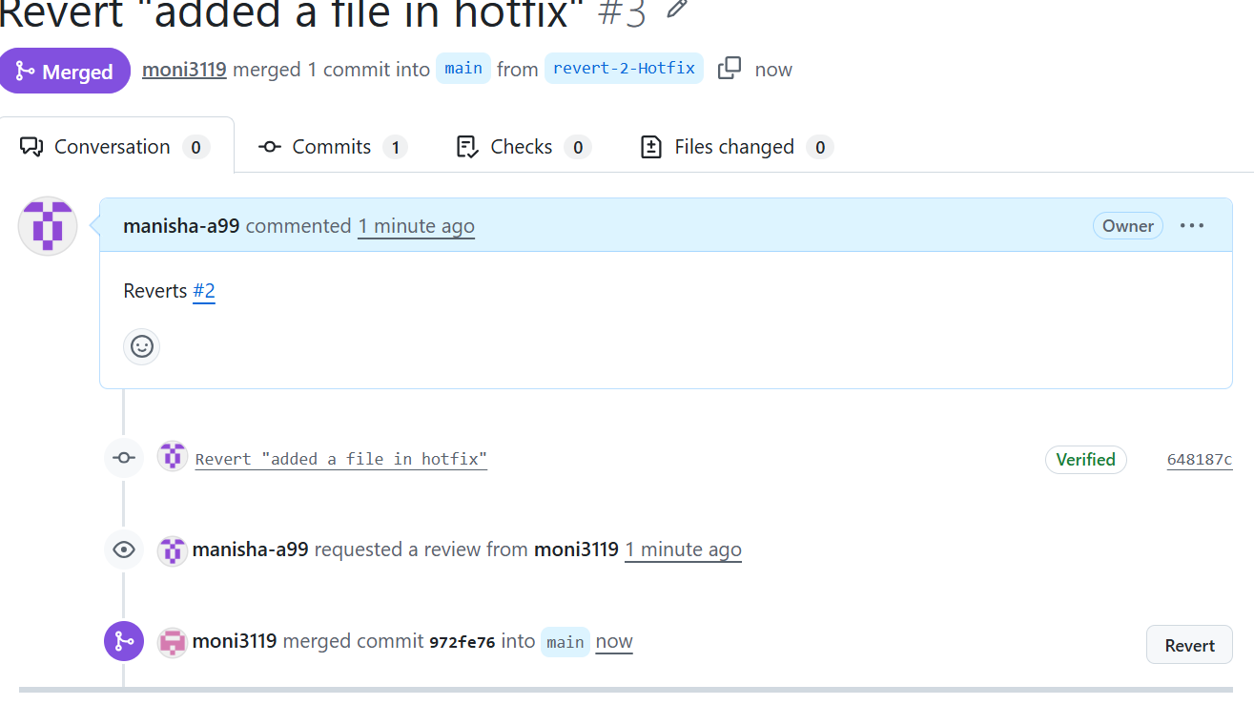

14.Recover lost commit:
Commit something, reset hard, and then recover it using git reflog.
